EASTERN INTERNATIONAL UNIVERSITY
BECAMEX BUSINESS SCHOOL


IN-TERM TEST

Course: MIS 443 -Business Data Management
Instructor’s name:Mr. Dang Thai Doan
Prepared by Pham Thuy Trang
IRN: 2332300158

Date submission: 4/08/2026
Quarter: 4/2025-2026

I. INTRODUCTION:
This report presents the complete solution and analysis for the In-term Practical Test in Management Information Systems (MIS443). The primary objective of this exercise is to apply SQL querying techniques using PostgreSQL and pgAdmin 4 to solve practical business intelligence problems based on the Northwind Traders relational database.
The Northwind database models the commercial activities of an international trading enterprise, including customers, orders, products, and shipping logistics. The report covers the following key components:
Environment Setup: Database initialization, creating the exam schema, defining the students table structure with appropriate constraints, and populating student credentials.
Data Retrieval & Business Analytics: Demonstrating relational operations using multi-table JOINs, aggregate functions (COUNT, AVG), condition filtering for bulk product movements (WHERE), analyzing logistics carrier performance, and implementing advanced window functions (DENSE_RANK) for customer activity ranking.

II. IMPLEMENTATION AND RESULTS:

1. Question 1: Database Setup & Student Table Creation (10 marks)
Objective: Initialize the database, create the exam schema, define the students table, and insert the student's personal record.
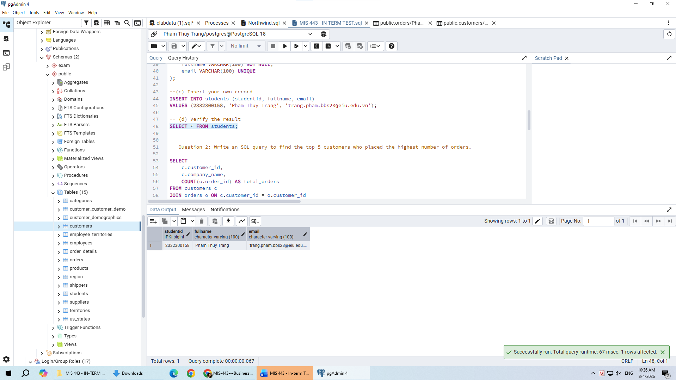

Question 2: Top 5 Customers with Highest Number of Orders (10 marks)
Objective: Retrieve the top 5 customers who placed the maximum number of orders.
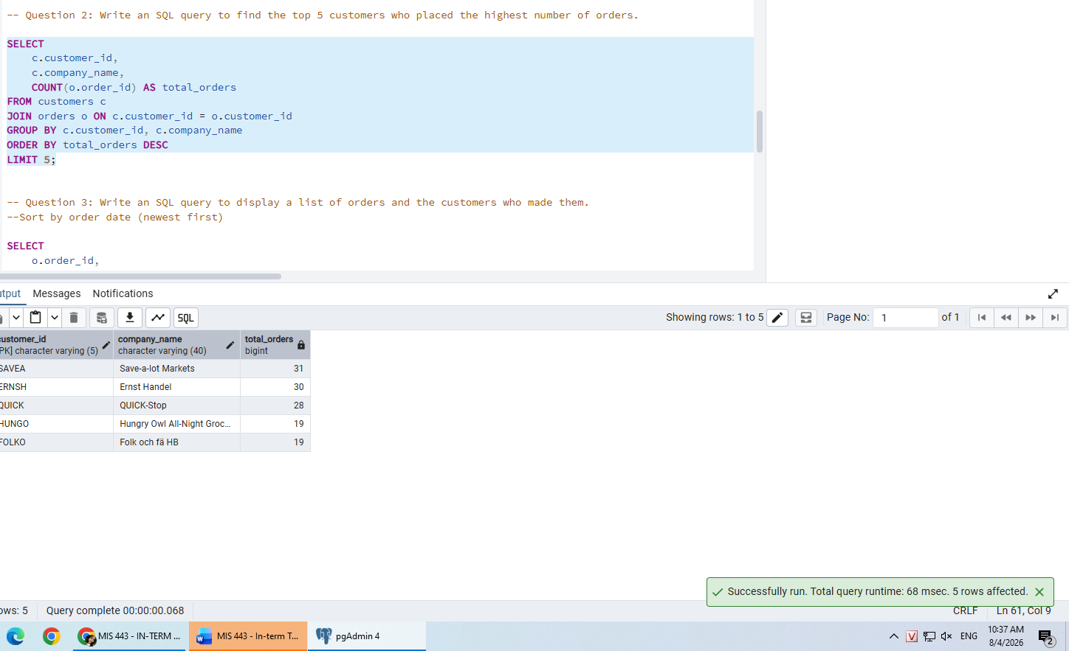
Joined the customers table (c) with the orders table (o) using the common key customer_id.
Utilized the aggregate function COUNT(o.order_id) combined with GROUP BY c.customer_id, c.company_name to calculate total orders per customer.
Applied ORDER BY total_orders DESC and LIMIT 5 to filter and extract the top 5 active customers.

3. Question 3: Order List with Customer Details (20 marks)
Objective: Display a comprehensive list of orders alongside their corresponding customer information, sorted by order date with the newest orders first.
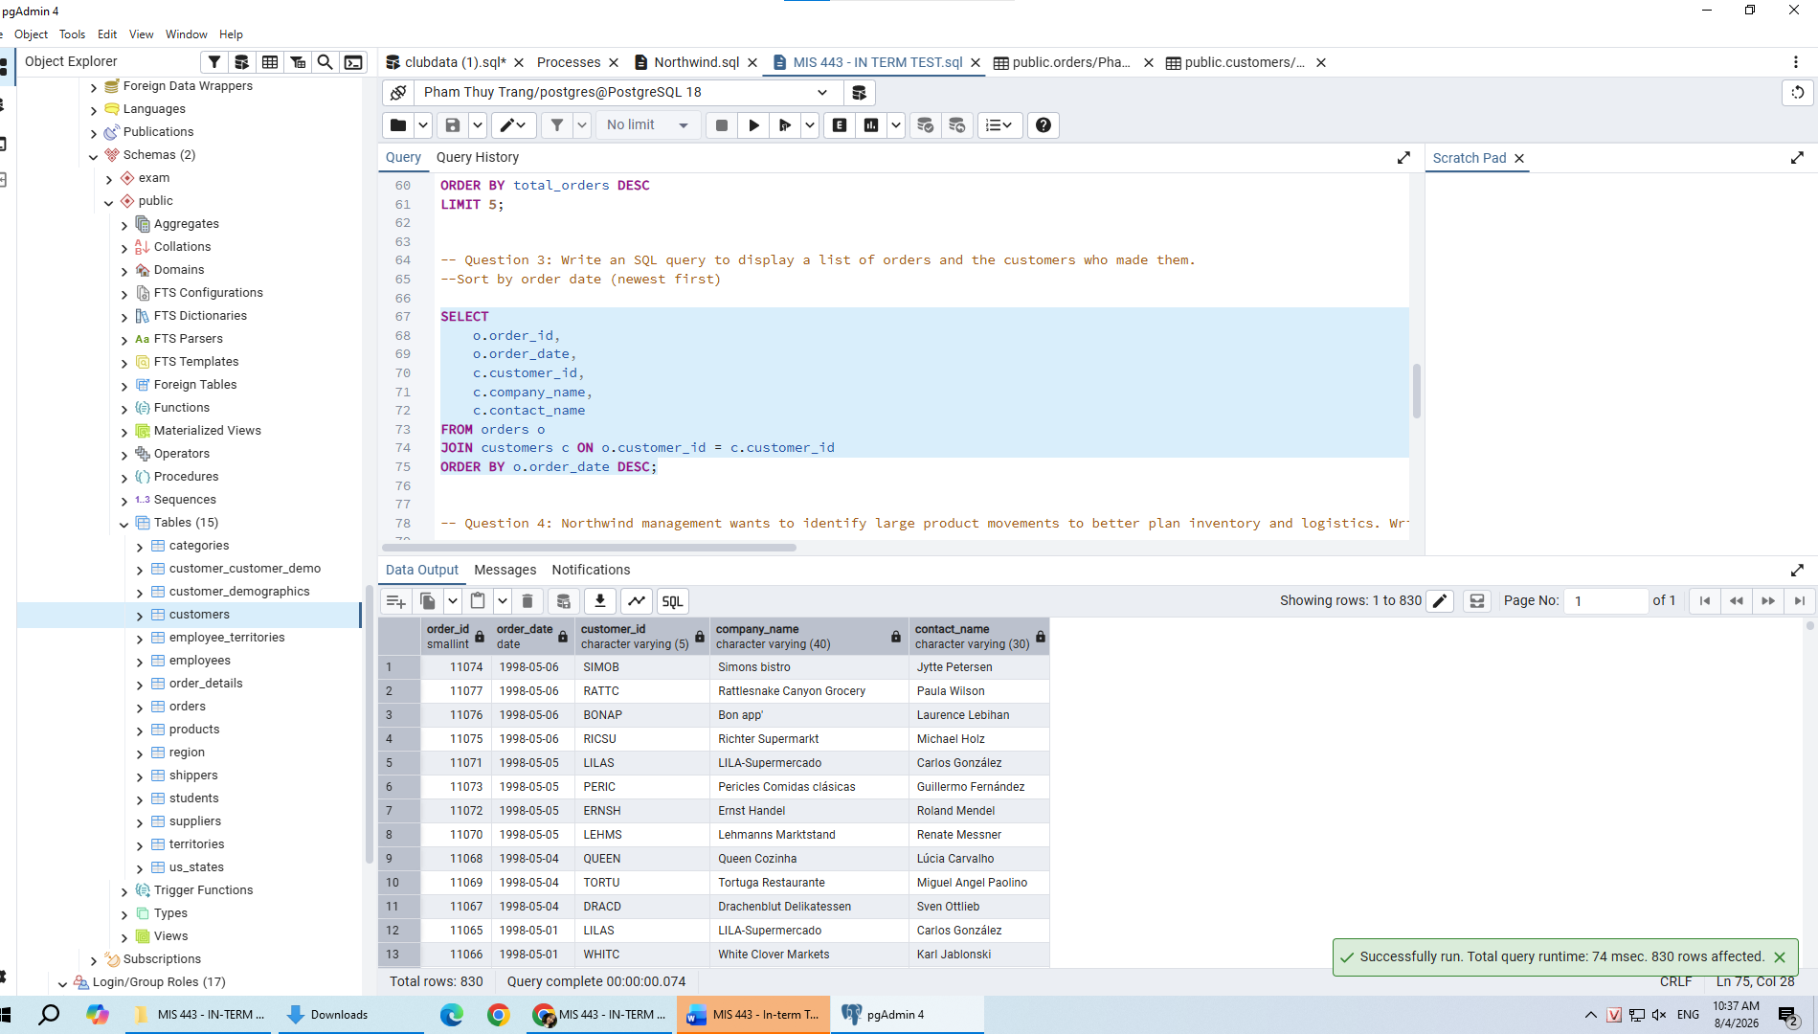
Executed an INNER JOIN between orders and customers based on matching customer_id values.
Selected relevant key fields: order_id, order_date, customer_id, company_name, and contact_name.
Used ORDER BY o.order_date DESC to ensure the list displays orders chronologically from newest to oldest (newest first).

4. Question 4: Filter Bulk Product Movements (> 99 Units) (20 marks)
Objective: Identify order items where products were purchased in large quantities (greater than 99 units) to assist management in logistics and inventory planning
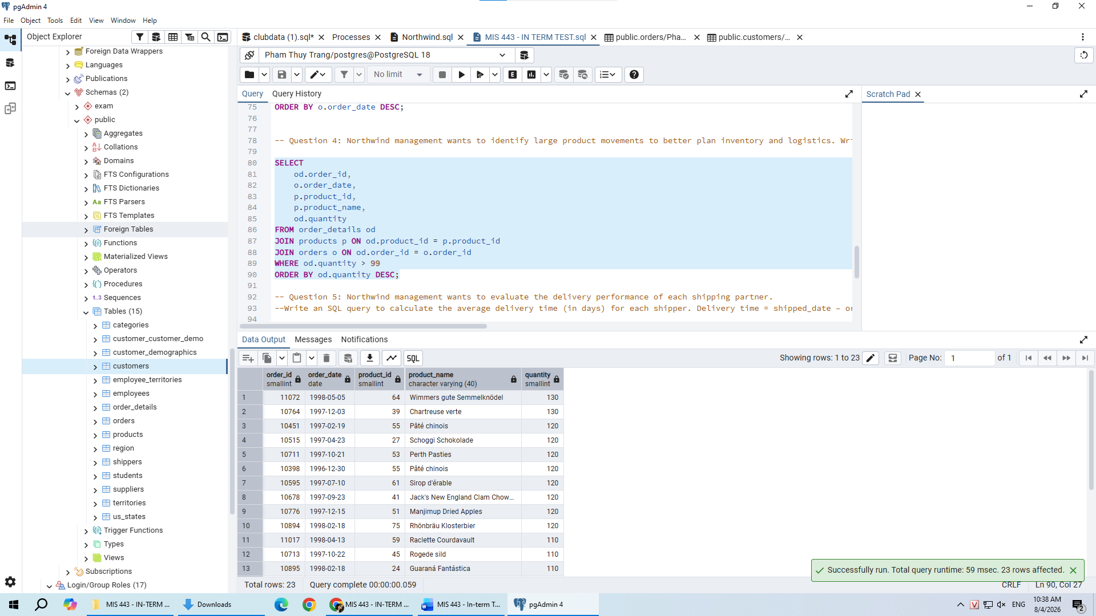

5. Question 5: Average Delivery Time per Shipping Partner (20 marks)
Objective: Evaluate logistics carrier efficiency by calculating the average delivery time (in days) for each shipping partner.
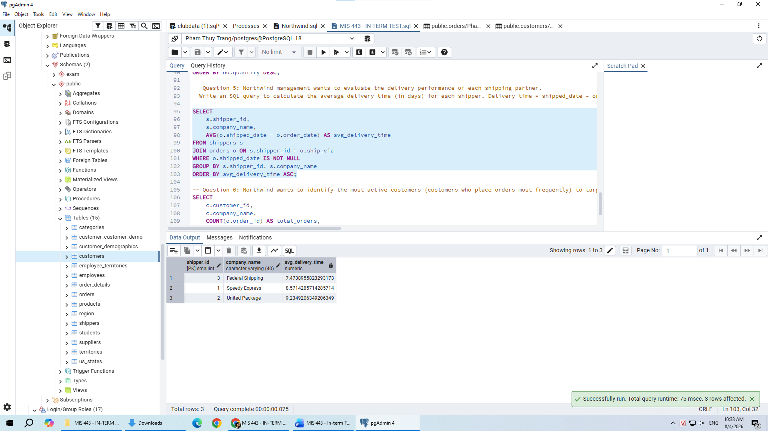

6. Question 6: Customer Ranking Based on Order Frequency (20 marks)
Objective: Rank active customers based on total order count to help Northwind target high-frequency purchasers.
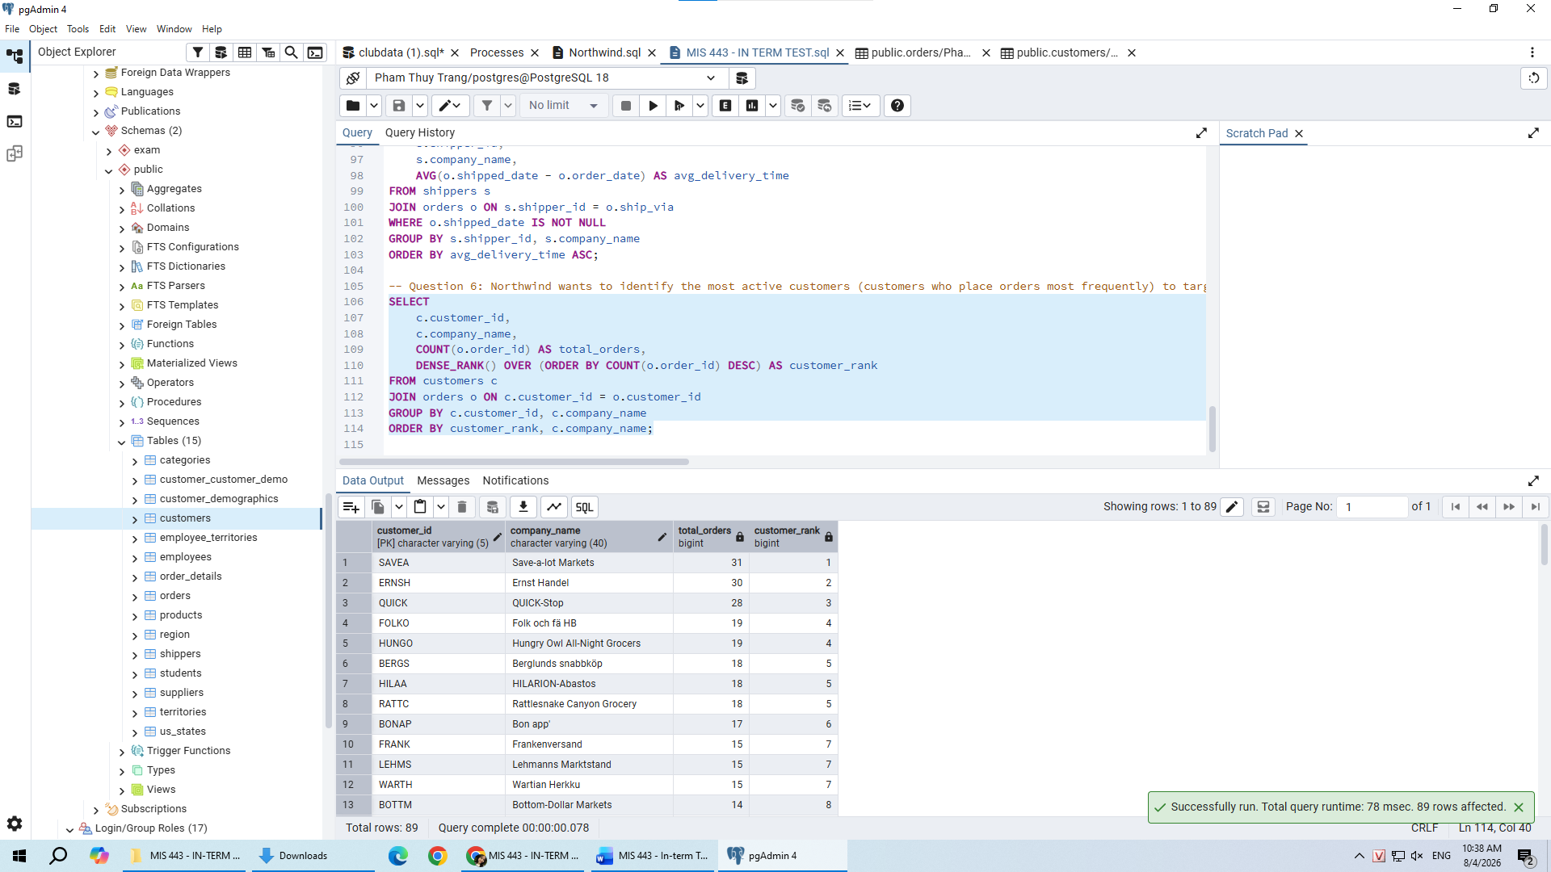
https://github.com/TrangPham-25/MIS-443---Business-Data-Management

